Big Data Vs Traditional Approach

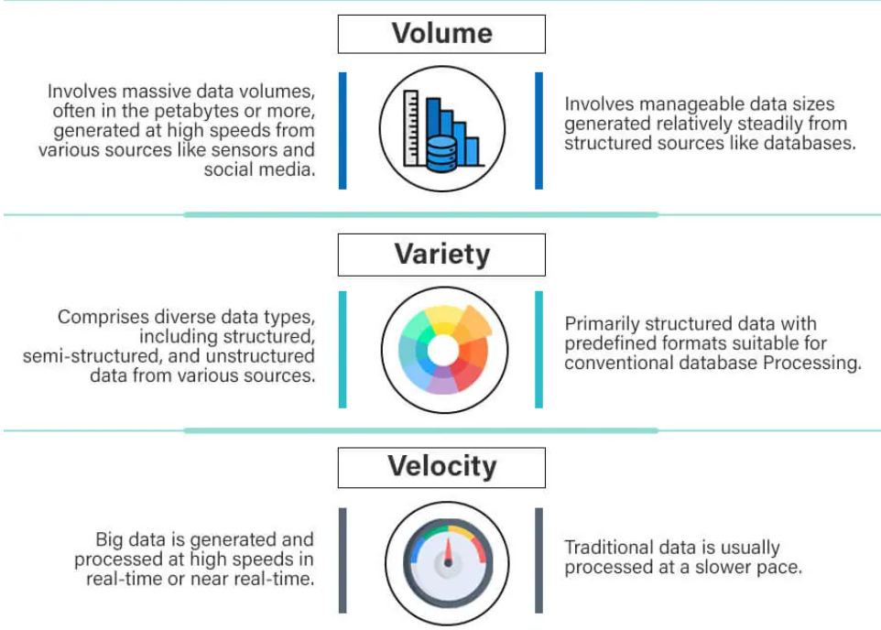

Big Data Vs Traditional Approach
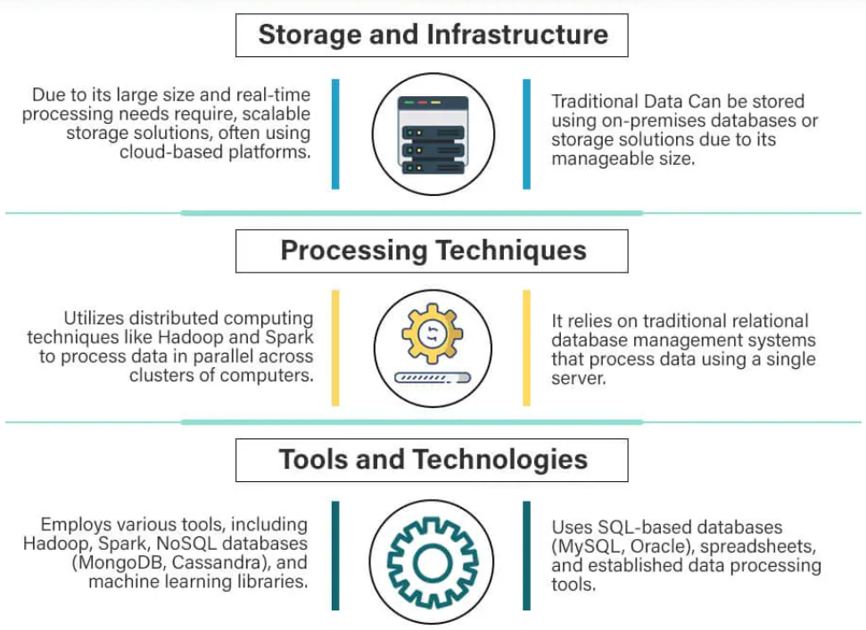

Big Data Vs Traditional Approach
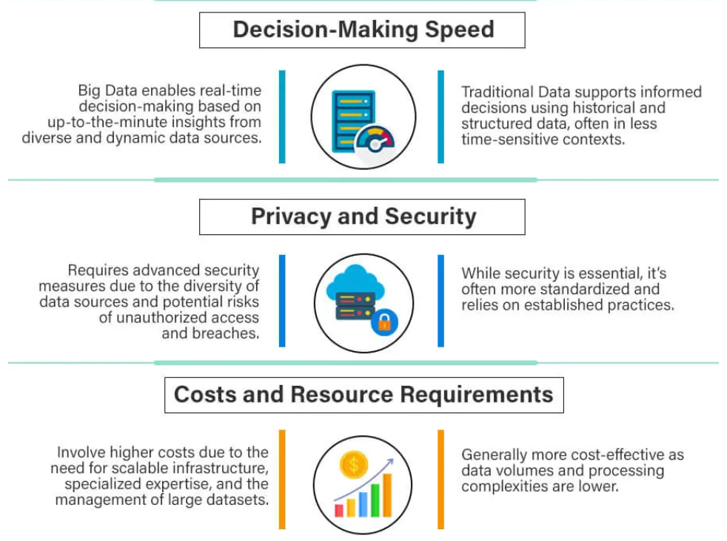

Big Data Vs Traditional Approach

